Modify the ActionBar app by altering the behavior when each action item is clicked in the following ways:
- When item1 through item4 is clicked, a TextView should be displayed at the upper-left, upper-right, bottom-left, and bottom-right on the screen, respectively.
- When item5 is clicked, all existing TextView that have been added to the screen should be cleared.

This app essentially consists of a single action bar in the upper right corner of the screen, which, when clicked, displays five items: items 1, 2, 3, 4, and clear at each of the four screen corners. Each item's position is set when it is clicked, and when we click the clear button, all of the items are cleared and the main activity resumes.

MainActivity.java : This employs a dynamic user interface within a “RelativeLayout”. We are using the “AppCompatActivity” which helps to support the older versions of android and action bar features. We are using methods like “onCreate”, “onCreateOptionsMenu”, onOptionsItemSelected” for predefined layout, to inflate a menu which is defined in XML file into action bar and to trigger when the menu is selected. In this context of event-driven programming, using if-else statements is a wise strategic move since they provide different reactions to user inputs and flexibility for future growth or adjustment of menu item behaviors.

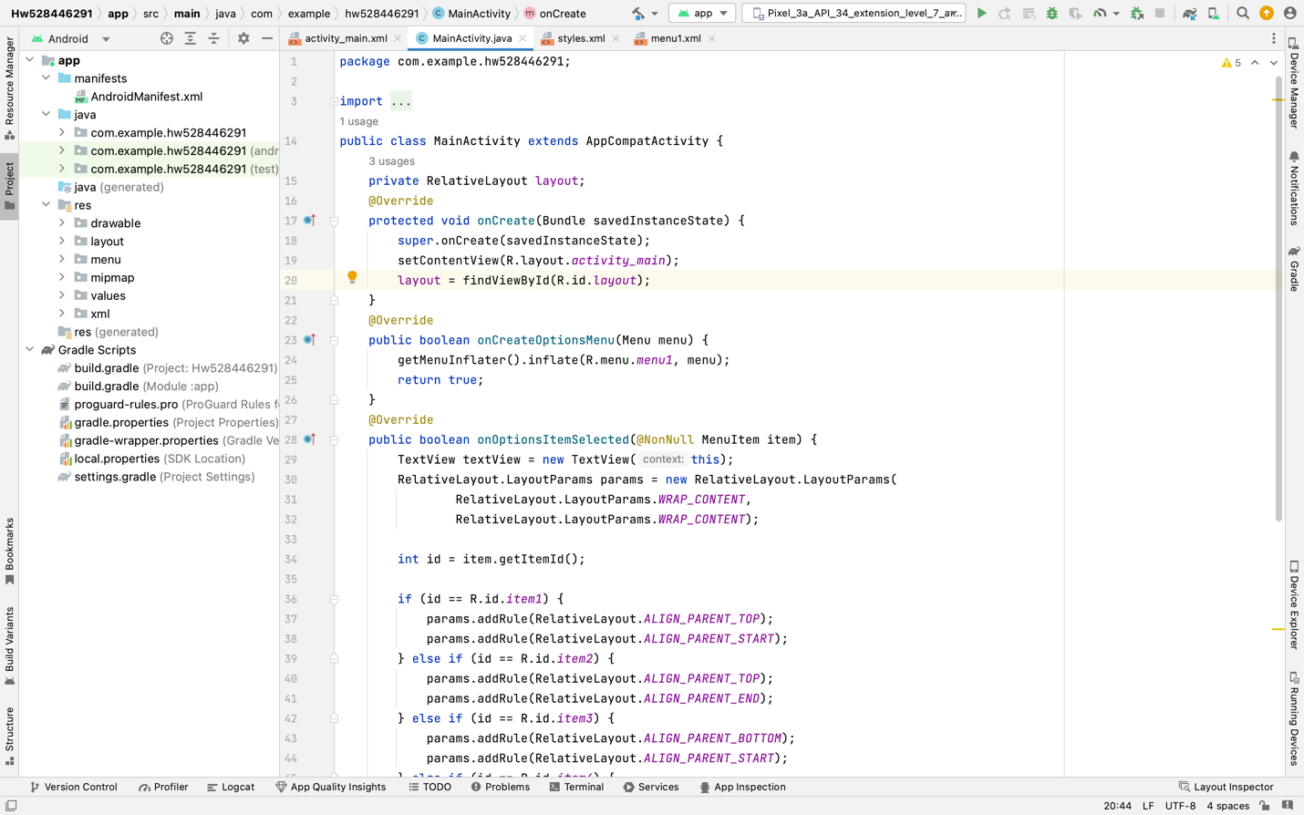

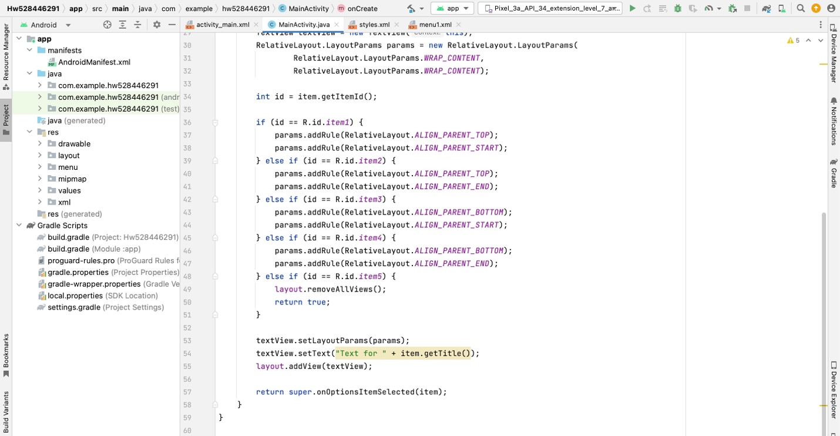
activity_main.xml : This defines the layout for the app using “RelativeLayout” as a root container which is suitable for the simple layouts like this which allow for the flexible positioning of the child elements. Within the layout there is a single “TextView” element which is configured to display the text “welcome to the app” and is position at the center of the screen we can also add other text and buttons if necessary.

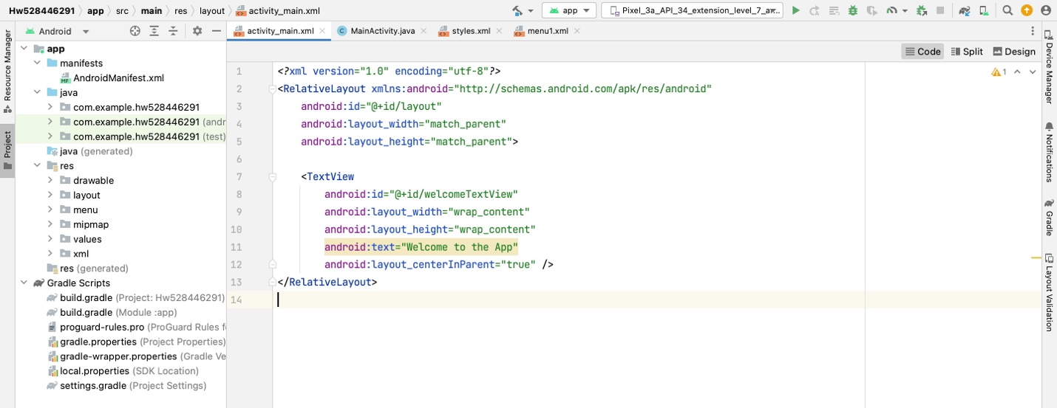

Menu1.xml : The layout for the menu option which is called in the “MainActivity” and we ae using method “onCreateOptionsMenu” for menu inflation and “onOptionsItemsSelcted” where it does not directly call the “menu1” but to handle the selection of item in “menu1.

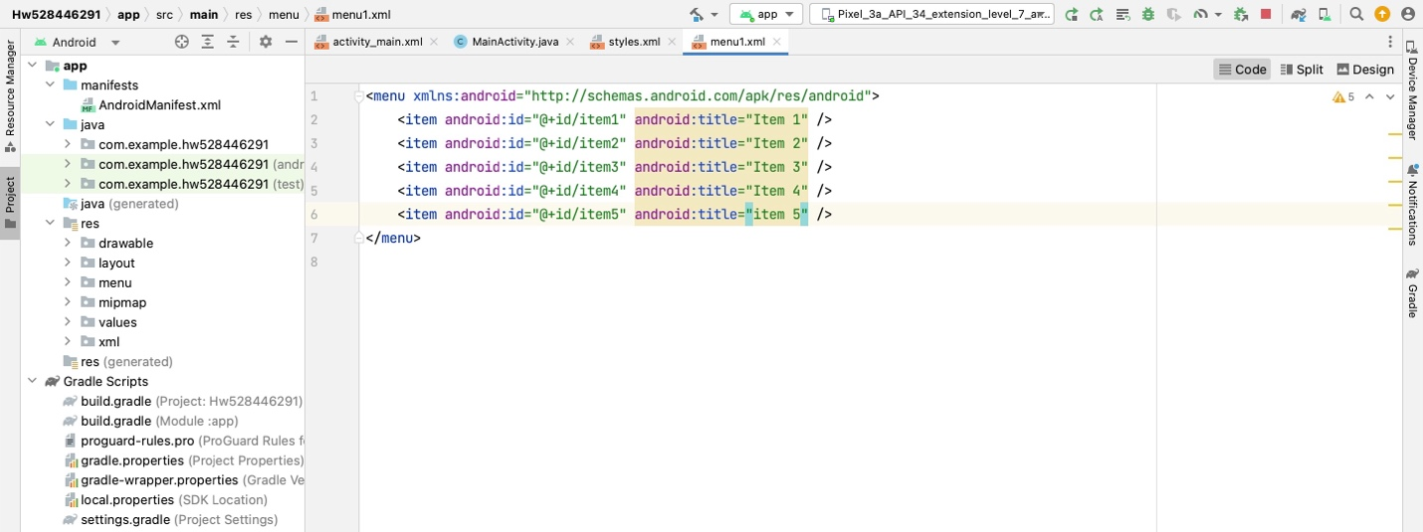

Style.xml : This is the xml layout for the theme of app which has light color in the background with dark action bar we ae using “Theme.AppCompat.Light.DarkActionBar” for this.

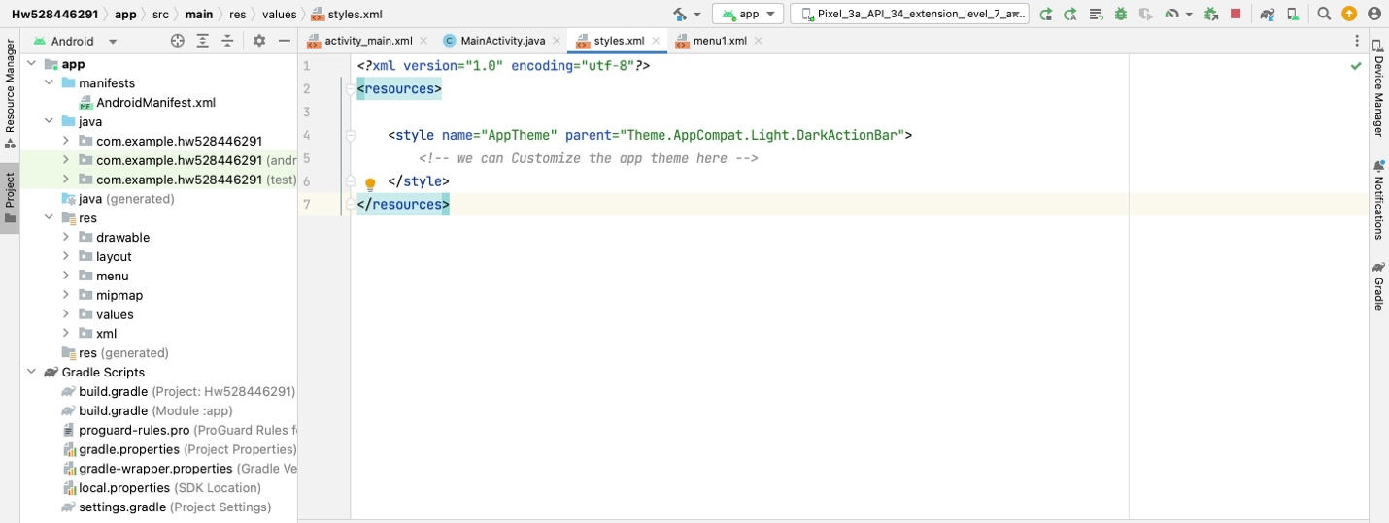

Below are the screen shots of the application:

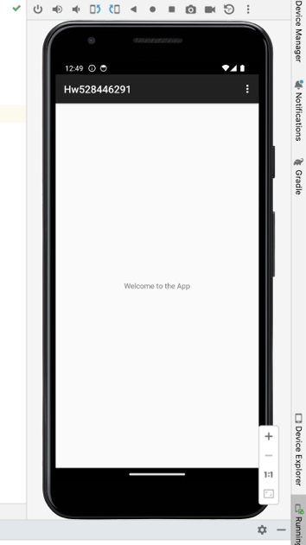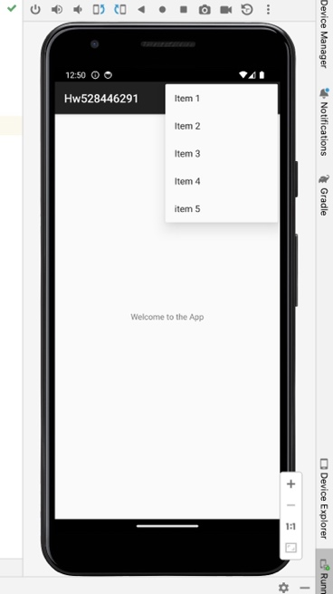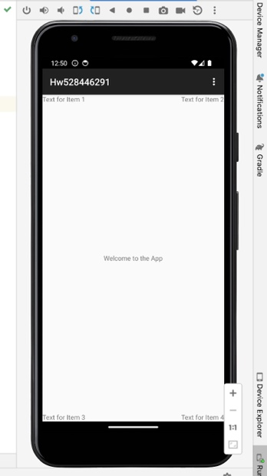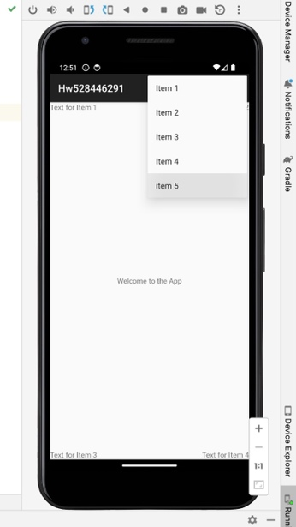

SS1(MainActivity). SS2(Items1 to 5). SS3 & SS4(items on four sides of the screen)

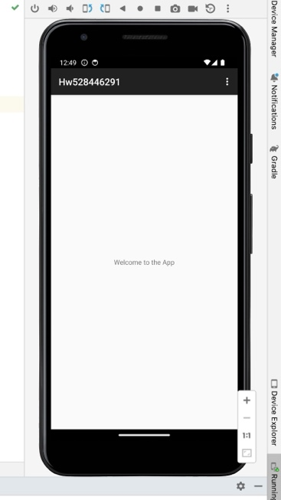

SS5(all items cleared when item5 is clicked)

